Gene Editing Services
Through a collaborative partnership with the UCLA Human Stem Cell and Genome Engineering Center (HSCGEC), we provide advanced genome engineering services using CRISPR, TALEN, and base editing technologies to support functional genomics, disease modeling, and tool development in pluripotent stem cells. Our comprehensive pipeline covers design, vector cloning, genome editing, and clonal isolation, enabling investigators to correct disease-associated mutations, introduce reporters, or perform complex genetic perturbations.
A. Gene Knockout Strategies
- Population Knockout: High-efficiency generation of edited pools, ideal for rapid screening and proof-of-concept studies.
- Clonal Knockout: Isolation of single-cell derived clones with fully validated genotypes.
- Conditional Knockout: Design of alleles for inducible or tissue-specific gene disruption.
B. Targeted Regulation & Insertion
- CRISPR Activation/Inhibition (CRISPRa/i): Integration into the AAVS1 safe harbor locus for stable, targeted gene activation or repression.
- AAVS1 Transgene Insertion: Precise knock-in of transgenes (e.g., reporters, overexpression cassettes) for predictable expression without random integration.
- Multiplexed gRNA Vectors: PiggyBac-mediated insertion of 3× gRNA vectors for complex genetic perturbations.
- Design & Consulting: Support for vector construction, including custom designs, for investigators performing transfection/selection in their own labs.
Deliverables
- Genetically engineered iPSC lines with validated genotypes
- QC documentation including confirmation of on-target edits and off-target assessment
- Optional clonal expansion and banking of edited lines
- Documentation suitable for publications or internal records

https://drive.google.com/drive/folders/1W5he7ZymwIhnmu0wH4fOr6GUgsX2iYpu?usp=sharing
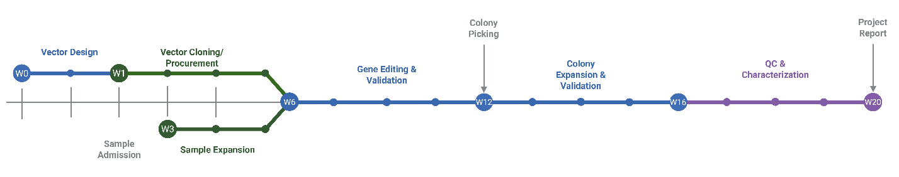

Service | Price | Add. Clones (After 3rd) | Timeline
Gene Knockout - Population | $3,750 | NA | 10-12 Weeks
Gene Knockout - Clonal | $6,750 | $500 | 12-20 Weeks
Gene Knockout - Conditional | $7,250 | $500 | 16-20 Weeks
CRISPR Act. / Inh. (AAVS1) | $9,000 | $500 | 16-20 Weeks
3x gRNA PiggyBac Vector Insertion | $6,250 | $500 | 16-20 Weeks
AAVS1 Gene Insertion | $9,000 | $500 | 16-20 Weeks
* Basic Gene Editing Service typically takes 4–6 months and includes expansion and sequence validation of 3 modified clones, sterility/mycoplasma testing, freeze–thaw viability, pluripotency marker staining, and CNV analysis. Additional services, such as tri-lineage differentiation assays, are available upon request.
Cell line-specific mutations/alterations may cause variability and potential delays. Additional clones can be requested for an extra fee.
Gene Editing Design & Cloning Service
Service | Price | Timeline
Reporter Cell Line Generation | $3,750 | 2-8 Weeks
Base Editor | $3,750 | 2-8 Weeks
Mutation / Correction | $2,750 | 2-8 Weeks
* Gene Editing Design & Cloning Service includes design and procurement of materials for reporter cell line generation, base editing, and mutation/correction studies. Timelines may vary depending on target complexity, and additional optimization or cloning efforts can be requested for an extra fee.

