iPSC Generation Service
Transform patient-derived fibroblasts or PBMCs into stable, expandable induced pluripotent stem cells (iPSCs) using integration-free methods. Our facility produces high-quality, patient-specific lines that enable disease modeling, including the study of genotype-phenotype correlations, and drug discovery applications for validating therapeutic targets in disease-relevant human cells. Generated lines are fully compatible with downstream applications, including genome editing, functional assays, and QC workflows.
Key Benefits
- Validated Quality: Lines are reproducible, stable, and free of reprogramming vectors.
- Validated Workflows: Optimized protocols for high efficiency and reproducibility.
- Downstream Compatibility: Fully compatible with our QC, characterization, and gene editing pipelines.
- Integration-Free: Avoids genomic integration of reprogramming factors.
- Scalable: Workflows support single-patient studies and larger cohort-based projects.
Deliverables
- Fully characterized, patient-specific iPSC lines ready for downstream applications
- QC report documenting pluripotency, viability, and sterility
- Documentation suitable for internal records, publications, or regulatory submission
IPSC Reprogramming Timeline
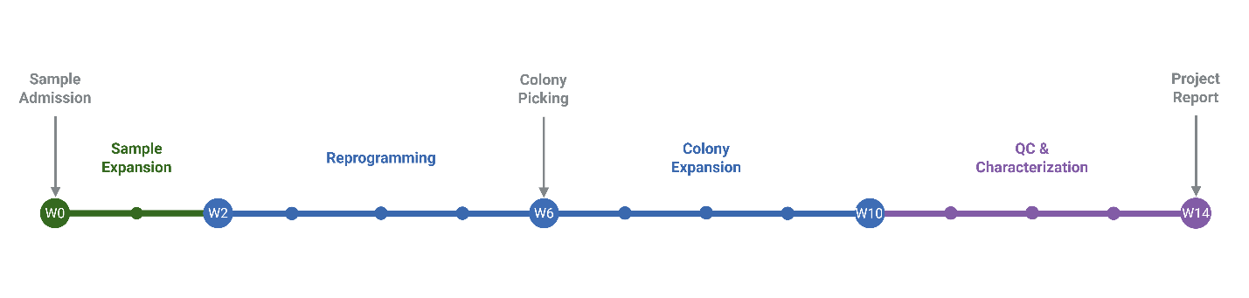
https://drive.google.com/drive/folders/1n9spYaapdsnxOrF9-HHssuBEvz0nLWEJ?usp=sharing

IPSC Reprogramming Service Table
Service | Price | Add. Clones (After 3rd) | Timeline
Reprogramming | $6,750 | $500 - $1000 | 14 weeks
CNV Analysis (WGS 0.3X) | $59.5 (gDNA) | NA | 4-6 weeks
Immunofluorescence of Pluripotency Markers | $60 | $20 | 4 weeks
Trilineage Differentiation Assay | $300 | $100 | 4 weeks
* Basic Reprogramming Service typically takes 4–6 months and includes expansion and sequence validation of 3 modified clones, sterility/mycoplasma testing, freeze–thaw viability, pluripotency marker staining, and CNV analysis. Additional services, such as tri-lineage differentiation assays, are available upon request. Patient-specific mutations may cause variability and potential delays. Additional clones can be requested for an extra fee.

